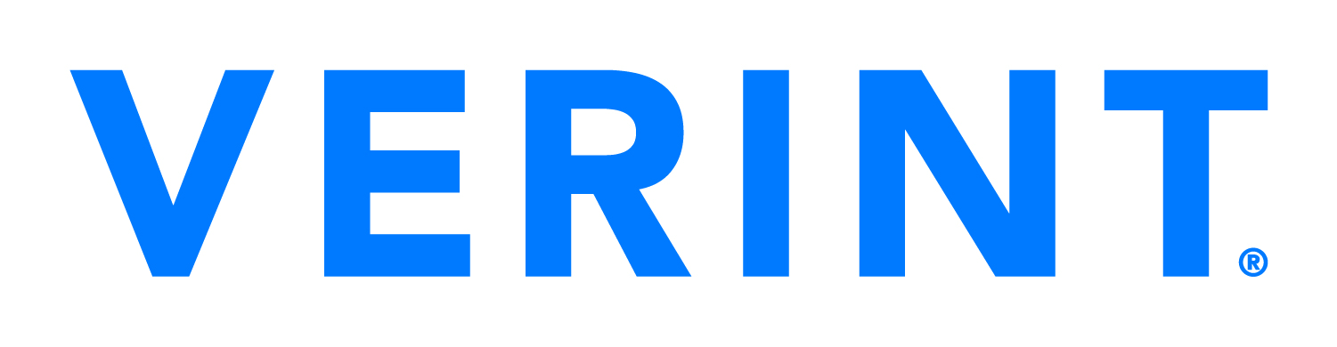

Press Release

Verint to Announce Second Quarter Financial Results on Wednesday, September 6, 2023

MELVILLE, N.Y., August 24, 2023 — Verint® (NASDAQ: VRNT) will conduct a conference call on Wednesday, September 6, 2023 at 4:30 p.m. ET to review its second quarter financial results (for the quarter ended July 31, 2023) and discuss its outlook. An earnings press release will be issued after the market closes on September 6th.
A real-time webcast of the conference call with presentation slides will be available on Verint's Investor Relations webcast page. Participants may register for the call here to receive the dial-in numbers and unique PIN to access the call. Please join the call 5-10 minutes prior to the scheduled start time.

About Verint
Verint® (NASDAQ: VRNT) helps the world’s most iconic brands continuously elevate the customer experience (CX) and reduce operating costs. More than 10,000 organizations in 175 countries – including over 85 of the Fortune 100 companies – rely on Verint’s open customer engagement platform to harness the power of data and AI to maximize CX automation.

Verint. The Customer Engagement Company®. Learn more at Verint.com.

This press release contains “forward-looking statements,” including statements regarding expectations, predictions, views, opportunities, plans, strategies, beliefs, and statements of similar effect relating to Verint Systems Inc. These forward-looking statements are not guarantees of future performance and they are based on management's expectations that involve a number of risks, uncertainties and assumptions, any of which could cause actual results to differ materially from those expressed in or implied by the forward-looking statements. For a detailed discussion of these risk factors, see our Annual Report on Form 10-K for the fiscal year ended January 31, 2023, and other filings we make with the SEC. The forward-looking statements contained in this press release are made as of the date of this press release and, except as required by law, Verint assumes no obligation to update or revise them or to provide reasons why actual results may differ.

VERINT, VERINT DA VINCI, VERINT OPEN CCAAS, THE CUSTOMER ENGAGEMENT COMPANY, BOUNDLESS CUSTOMER ENGAGEMENT, AND THE ENGAGEMENT CAPACITY GAP are trademarks of Verint Systems Inc. or its subsidiaries. Verint and other parties may also have trademark rights in other terms used herein.

###

Investor Relations Contact:
Matthew Frankel, CFA
Verint Systems Inc.
(631) 962-9672
matthew.frankel@verint.com

